When looking into the various data modeling techniques that are used for visualizing data sets, I was able to see how each one had its uses. The different strategies that I was able to find were conceptual data models, logical data models, and physical data models. Conceptual data models revolve around the concept of displaying physical information sets via a graph. An example of this would be if a company tried to display the number of products that they have sold over the course of a year, they would have a table with the date of the sale, the name of the product, and the store locations the sale occurred at. Logical data models provide more detail in their information. To be more descriptive about it, “Logical data models can be useful in highly procedural implementation environments, or for projects that are data-oriented by nature, such as data warehouse design or reporting system development.” (Jonker, Russi, & Scapicchio, n.d.) The last technique I was able to find is physical data modeling. This involves when the data being visualized is stored inside databases that can be combined into one singular database to accomplish a singular goal. I would say that the trading-offs I saw between these three techniques were the scalability and accuracy of each one. Physical data models provide high data accuracy but have poor scalability due to the amount of data it contains through all its different data sets. Conceptual data models are efficient in being able to scale them appropriately, but do not provide too much accuracy when providing details. Logical data models are more of the middle ground between scalability and accuracy. Depending on how much data the user is trying to account for when creating their data models, different data modeling techniques would want to be used.
When looking into which data modeling approach I wanted to use for combining the two given data sets in this assignment, I wanted to use the model type that uses a lot of information to take in as much detail as possible. This would make my choice to use physical data modeling. There was a lot of information to consider that did not all line up exactly, so I believed that using physical data modeling would be my best choice. This was the best choice for the data I was given because it allows me to combine similar data pieces that contain enough significance to be viewed from a combined data set. As quoted from the website IBM, “They offer a finalized design that can be implemented as a relational database, including associative tables that illustrate the relationships among entities.” (Jonker, Russi, & Scapicchio, n.d.) Considering that the two data sets have the same data columns of “Nutrient code,” “Date added,” and “Last modified,” it lets me be able to combine the data sets into one that provides as much adaptability as possible. If someone were creating a diet plan for a child, they can now pull more data about the protein value of a certain food per unit using the combined data set.
Considering the kind of data that I needed to use, this was the graph I was able to create:
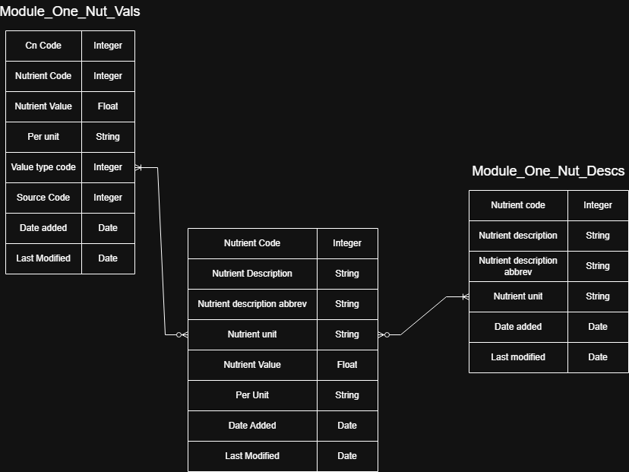
Looking at the created combined data set, I was able to combine the given data in a way that provides a large amount of scalable data through combining identical data columns. If I know the nutrient code of a nutrient, I can pull information from both data sets through that similar value. It also allows for flexibility by allowing me to take any form of data based on those similar data pieces.

References
Jonker, A., Russi, E., & Scapicchio, M. (n.d.). What is data modeling? Retrieved from IBM: https://www.ibm.com/think/topics/data-modeling

